TIME SERIES MODELLING AND FORECASTING OF CRUDE OIL PRICES USING ARMA AND LSTM APPROACHES

Name: NASAR REDDY NARU
Student Id: 23100228
GitHub: Nasarreddy903@gmail.com

ABSTRACT
This paper analyzes crude oil price fluctuations based on time-series forecasting models. The data on oil prices in 20242026 were predicted using Autoregressive Moving Average (ARMA) and Long Short-Term Memory (LSTM) neural networks. ARMA and LSTM modelling were performed using stationarity tests, parameter optimisation, and residual diagnostics, and scaled sequential data, respectively. Findings indicate that LSTM models are more effective at describing nonlinear behaviour and short-term price fluctuations.

1. INTRODUCTION

Background of Oil Price Forecasting:
Oil-price prediction has become a hot academic topic since crude oil is the key to ensuring economic stability all over the world and to the growth of industry. Cyclic changes of oil prices affect the transportation cost, production cost, and financial markets of the global sphere. This has led to many forecasting models, econometric and machine-learning methods, being developed by researchers to enhance the predictive accuracy (Wang, 2024; Fu, 2023).

Importance of Time Series Modelling in Energy Markets:
The time-series modelling is critical in analyzing the past energy-price data and to determine the trends, volatility, and patterns of analysis over time. Proper forecasting would help the governments, investors, and energy companies to control risks, arrange investments, and make sound economic and policy-based decisions in the unstable energy markets (Rao et al., 2025).

Aim and Scope of the Study:
The proposed research will examine the time-variations of crude oil prices employing time-series analysis and test the forecasting accuracy of ARIMA and LSTM models. The study aims at improving the prediction efficiency by using the previous oil-price information.

2. DATA DESCRIPTION AND EXPLORATORY ANALYSIS

Dataset Overview:
The data set includes historical prices of crude oil data that has been discovered between September 2024 and February 2026 and consists of 500 daily data. The main variable to be analysed is the oil price in the US dollars.

Table 1: Descriptive Statistics (Source: Python)
Statistic | Price (Dollars)
Mean | 75.873980
Standard Deviation | 42.912398
Minimum | 16.480000
Median (50%) | 64.290000
Maximum | 158.780000

Initial Visualisation of Oil Prices:
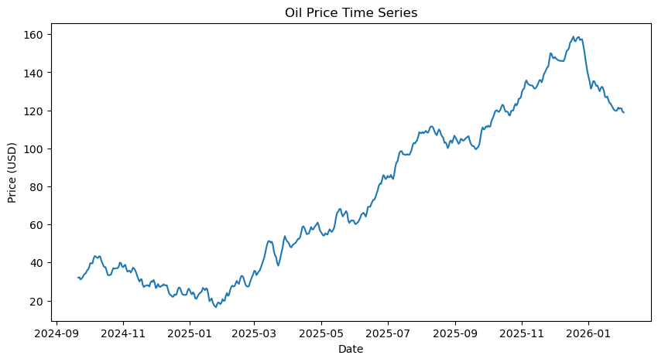
Figure 1: Time Series Plot of Oil Price (Python)
The time-series plot reveals some significant variations and changes of trends. Prices declined during late 2024 and early 2025 before increasing significantly in mid-2025. Long-term volatility implies volatile market behaviour that is characteristic of energy prices.
Preliminary Observations:
Preliminary examination shows that there are trends and variability and therefore might be non-stationary. All these features warrant the use of time-series forecasting methods that have the ability to model both linear and nonlinear trends.

3. METHODOLOGY

3.1 ARMA Time Series Model
Concept of ARMA Models:
ARMA models are one of the most common methodology frameworks of analyzing and predicting stationary time-series. The models combine autoregressive (AR) terms, which capture terms of dependence on the observed antecedents, and moving-average (MA) terms, which represent the terms of error structure of the past. Using this composition ARMA specifications can be used to model linear temporal interdependencies of time-series data (Tsoku et al., 2024).
The ARMA-based procedures continue to maintain significant popularity in energy economics due to their capacity to capture the short-term price variances and embedded cause-and-effect relationships (Hossain et al., 2025).
Model Identification and Stationarity:
Identification of suitable lag structure was performed using a visual examination of Autocorrelation Function (ACF) and Partial Autocorrelation Function (PACF) plots where the parameter space was determined as below:
p ∈ [0,8], d ∈ [0,2], q ∈ [0,8]
Each candidate configuration was tested using Akaike Information Criterion (AIC) and the specification with the least value of the AIC was chosen. The evaluation of stationarity was done through the Augmented Dickey Fuller (ADF) test; where non-stationarity was found, the mean was then stabilized with the use of first-order differencing before being estimated by a model (Hossain et al., 2025).

3.2 Alternative Forecasting Model – LSTM

Long Short-Memory (LSTM) networks This is a type of recurrent neural network that is specifically designed to learn the sequence of data and long-distance connections. The LSTM configurations can absorb the nonlinear temporal dynamics by their memory cell and gating mechanisms which provide appropriateness to the volatile financial and energy market data.
Oil-price observations were pre-training normalised through Min-Max scaling. To transform the series into a supervised learning problem, a sliding-window transformation was used to reframe the series generating input-output pairs. The training of the model was repeated in several epochs using the Adam optimiser as its goal and a reduction in the error of predictions (Zhao et al., 2024; Brown et al., 2024).
Recursive generation of future values was used to make use of the terminal observation window that helped in generating forecasts around a 24-month horizon. The model was used to measure forecast uncertainty using confidence bounds based on the residual variability.

4. RESULTS AND MODEL PERFORMANCE

4.1 ARMA Model Results

ADF Test Results:
The statistic of the Augmented Dickey-Fuller was 0.546 with a p-value of 0.882, which implied that the original series of oil-prices was non-stationary.
Differencing:
To correct non-stationarity, first order differencing was used to stabilize the mean.
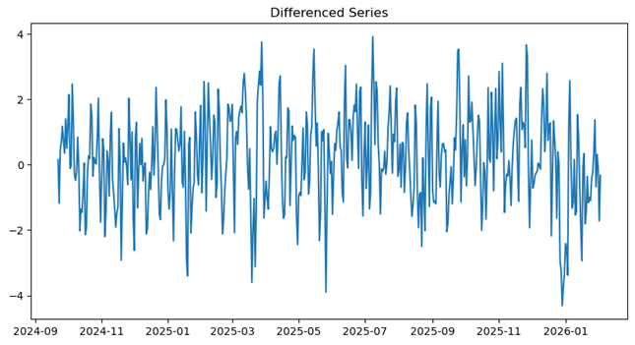
Figure 2: Differenced Oil Price Time Series Showing Stabilized Mean After Removing Non-Stationarity
(Source: Python)
The resultant series oscillates around a more consistent mean, which means that a stationary state has been attained.
ARMA Model Parameter Search:
Plots (ACF and PACF) were investigated to reveal lag relationships.
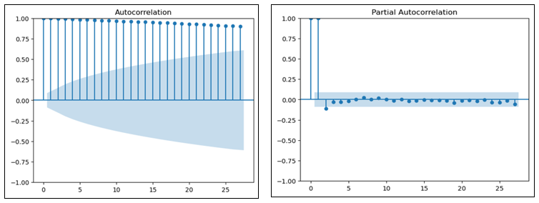
Figure 3: Autocorrelation Function (ACF) and Partial Autocorrelation Function (PACF) (Source: Python)
The AIC-based search algorithm was able to identify the best configuration, which was ARMA (3,2,5) with the minimum AIC value of 1125.72.
Residual Diagnostics:
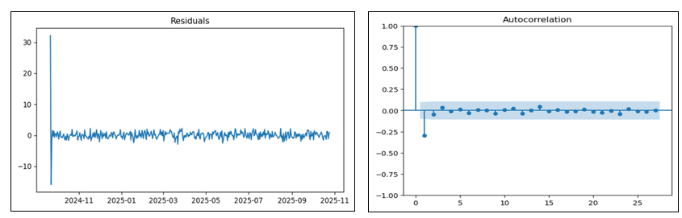
Figure 4: Residual Diagnostics of the Selected ARMA Model (Source: Python)
The residual diagnostics show random variable dynamics around the zero mark, and the autocorrelations do not exceed the boundaries of the confidence interval.
Forecasting Results:
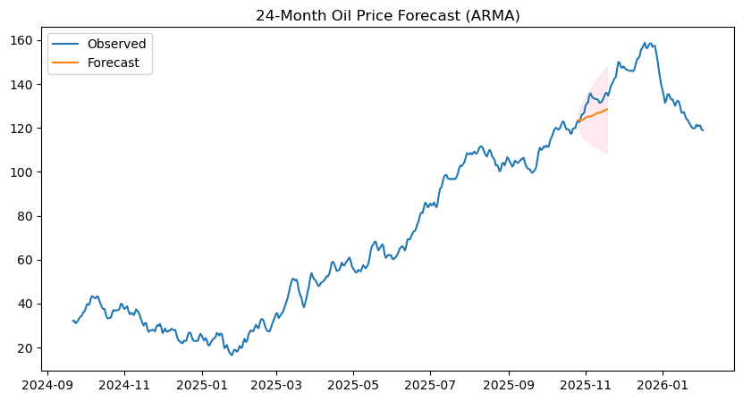
Figure 5: Forecasted Crude Oil Prices Using the ARMA Model (Source: Python)
The ARMA forecast predicts the further extension of the recent price behaviour and the confidence intervals are gradually growing, demonstrating the growing uncertainty of the prediction with the extension of the prediction horizons.

4.2 LSTM Model Results
Model Training and Prediction Performance:
The Long Short-Term Memory (LSTM) model was trained with the help of a sliding window of ten consecutive previous observations as the input features. It consisted of an LSTM layer with 50 units followed by a dense layer.
Through the training, the loss figure dropped as well as an initial figure of 0.1607 down to about 0.00056, and this indicates that the learning dynamics were successful.
Forecast Visualisation and Patterns Observed:
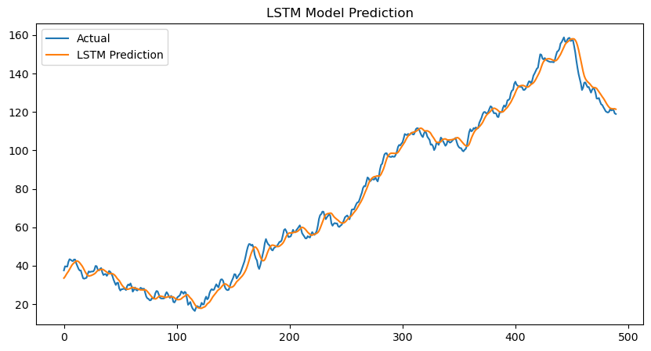
Figure 6: Predicted Crude Oil Prices Using LSTM
(Source: Python)
The predictions made are very much similar to actual oil price series and thus short-term fluctuations are better represented by the created predictions than by the ARMA model.
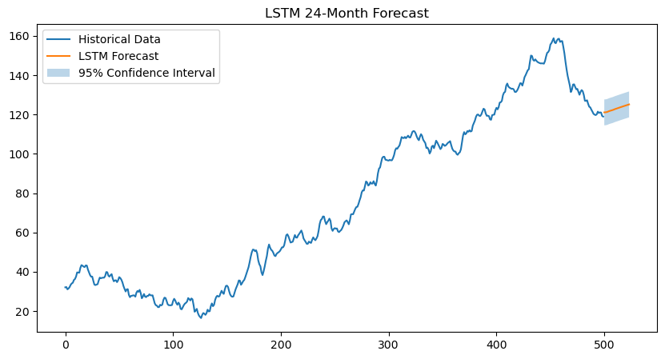
Figure 7: LSTM 24-Month Forecast
(Source: Python)
According to the forecast output, the trend of the oil prices is progressive upwards with the confidence intervals attached to indicate the inherent uncertainty of the predictions.
Evaluation Metrics and Interpretation:
Root Mean Squared Error (RMSE) = 3.37
This relatively low RMSE highlights a strong predictive capability of short-term predictions.

5. COMPARISON OF FORECASTING MODELS

RMSE Comparison
Table 2: RMSE Comparison of two models (Source: Python)
Model | RMSE
ARMA | 14.87
LSTM | 3.36

The significantly reduced RMSE of the LSTM model shows that the model predicts better compared to the ARMA model.
Forecast Behaviour and Model Characteristics
The ARMA model generates stable forecasts that are based on linear relationships in historical data. However, the dynamics associated with crude-oil prices are often nonlinear, which can be explained by the presence of market shocks, changes in demand, as well as by the impact of geopolitics. The LSTM framework is more qualified to capture these nonlinear trends hence making them capable of providing a more accurate prediction of observed price patterns.
Strengths and Limitations of Each Model:
ARMA models are simple to use and easy to interpret along with the fact that they often fail when faced with nonlinear behaviour. Conversely, LSTM based models have greater flexibility to the modelling of complex temporal relationships, although at the cost of increased data requirements and computational cost.

6. DISCUSSION AND INTERPRETATION OF FINDINGS

Explanation of Observed Model Behaviour:
The differences in model results indicate similar assumptions. Although ARMA is based on the linear relationships between the previous data and error values, which in turn results in predictable but less flexible forecasts, LSTM networks learn nonlinear relationships with each sequence of prices and enable the ability to follow unpredictable price patterns.

Factors Influencing Forecasting Performance:
The macroeconomic activity, and the supply conditions, as well as the geopolitical events all contribute to the formation of the nonlinear dynamics in the price of crude-oil (Agan et al., 2026). In this regard, machine-learning, e.g., LSTM strategies, tend to achieve improved predictive accuracy when faced with multi-dimensional energy-market data.

7. CONCLUSION AND FUTURE IMPROVEMENTS

The current paper has proved that ARMA and LSTM models have the ability to predict the price of oil; however, the LSTM model has a strong ability to reproduce complex trends.
According to Ray et al. (2023), Future studies could enhance forecasting accuracy by:
- Incorporation of external macroeconomic factors, such as supply, demand and geopolitical factors.
- Building hybrid models that combine ARIMA and LSTM models.
- Increasing the dataset to cover a broader period of time.
- The use of sophisticated deep-learning deep-networks to enhance predictive performance.
- Applying advanced deep learning architectures for improved prediction performance.

REFERENCES
Agan, B., Yulek, M. and Çelik, S., 2026. Comparative performance of stochastic and deep learning models in forecasting crude oil prices under market shocks. Computers & Chemical Engineering, 206, p.109534. https://doi.org/10.1016/j.compchemeng.2025.109534
Brown, M., Chen, E., Lee, S., Taylor, J., Kim, A. and Johnson, R., 2024. Comparative analysis of LSTM and traditional time series models on oil price data. Preprints. https://doi.org/10.20944/preprints202410.2355.v1
Fu, X., 2023. Oil price forecasting model based on GARCH-LSTM model. Frontiers in Business, Economics and Management, 10(3), pp.28–31. https://doi.org/10.54097/fbem.v10i3.11205
Hossain, M.L., Shams, S.M.N. and Ullah, S.M., 2025. Time-series and deep learning approaches for renewable energy forecasting in Dhaka: a comparative study of ARIMA, SARIMA, and LSTM models. Discover Sustainability, 6, p.775. https://doi.org/10.1007/s43621-025-01733-5
Rao, A., Sharma, G.D., Tiwari, A.K., Hossain, M.R. and Dev, D., 2025. Crude oil price forecasting: Leveraging machine learning for global economic stability. Technological Forecasting and Social Change, 216, p.124133. https://doi.org/10.1016/j.techfore.2025.124133
Ray, S., Lama, A., Mishra, P., Biswas, T., Das, S.S. and Gurung, B., 2023. An ARIMA-LSTM model for predicting volatile agricultural price series with random forest technique. Applied Soft Computing, 149, p.110939. https://doi.org/10.1016/j.asoc.2023.110939
Tsoku, J.T., Metsileng, D. and Botlhoko, T., 2024. A hybrid of Box-Jenkins ARIMA model and neural networks for forecasting South African crude oil prices. International Journal of Financial Studies, 12(4), p.118. https://doi.org/10.3390/ijfs12040118
Wang, T., 2024. WTI crude oil price forecasting for the next year using ARIMA model. Highlights in Science, Engineering and Technology, 88, pp.804–809. https://doi.org/10.54097/c70fak89
Zhao, Y., Hu, B. and Wang, S., 2024. Application of LSTM models in forecasting Brent crude oil prices during the green energy transition. Advances in Economics, Management and Political Sciences, 132, pp.177–182. https://doi.org/10.54254/2754-1169/2024.18460

